**Assignment -4**

|  |  |
| --- | --- |
| Student Name | CHANDRU S |
| Team Id | PNT2022TMID04548 |
| Maximum Marks | 2 Marks |

1.Pull an Image from docker hub and run it in docker playground.

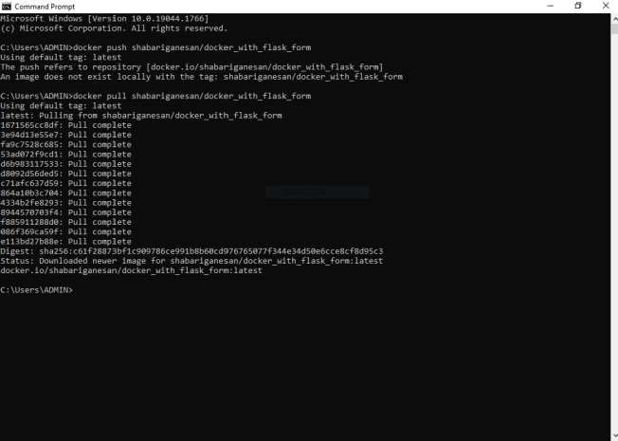

2.Create a dockerfile for the job portal / flask application and deploy it in Docker desktop application.

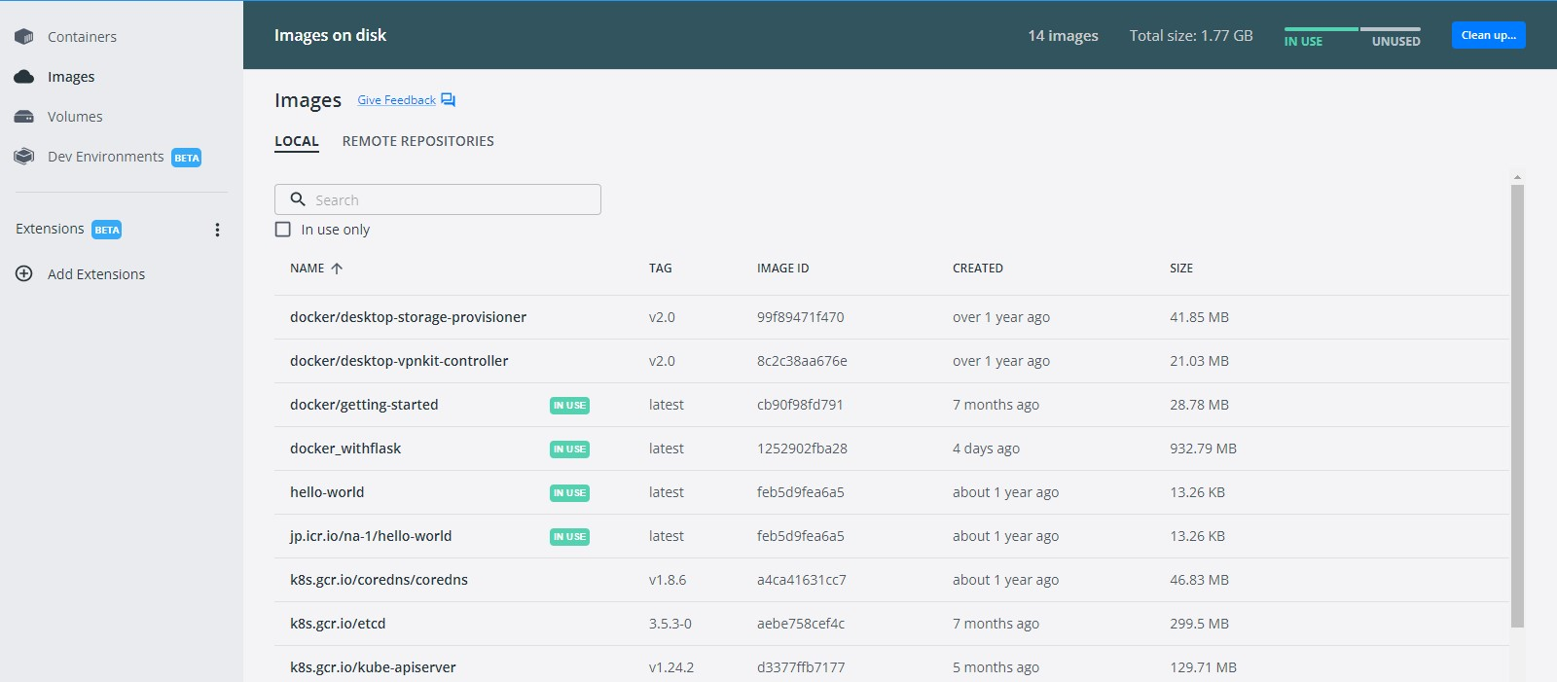

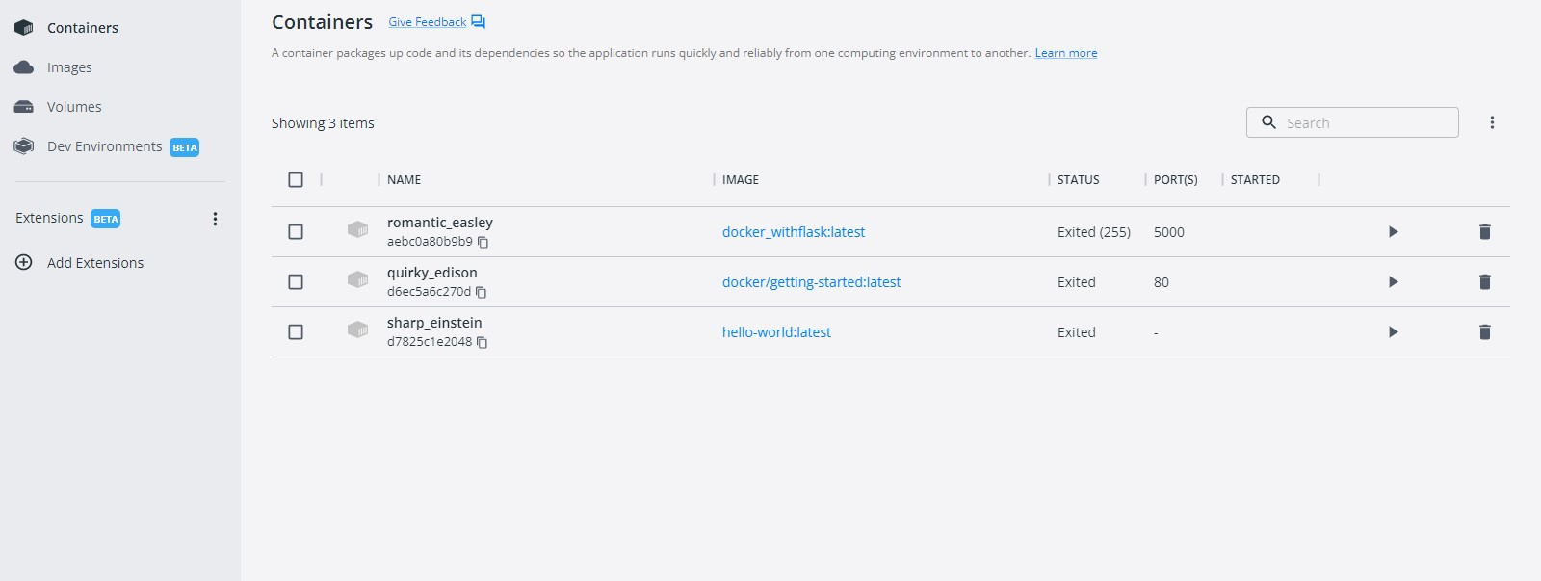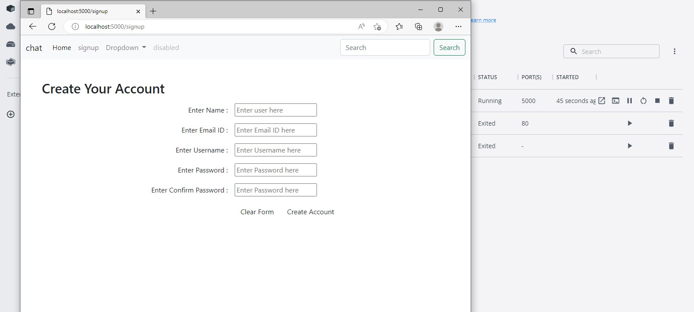

3.Create a **IBM container registry** and **push docker image** of flask application or job portal app.

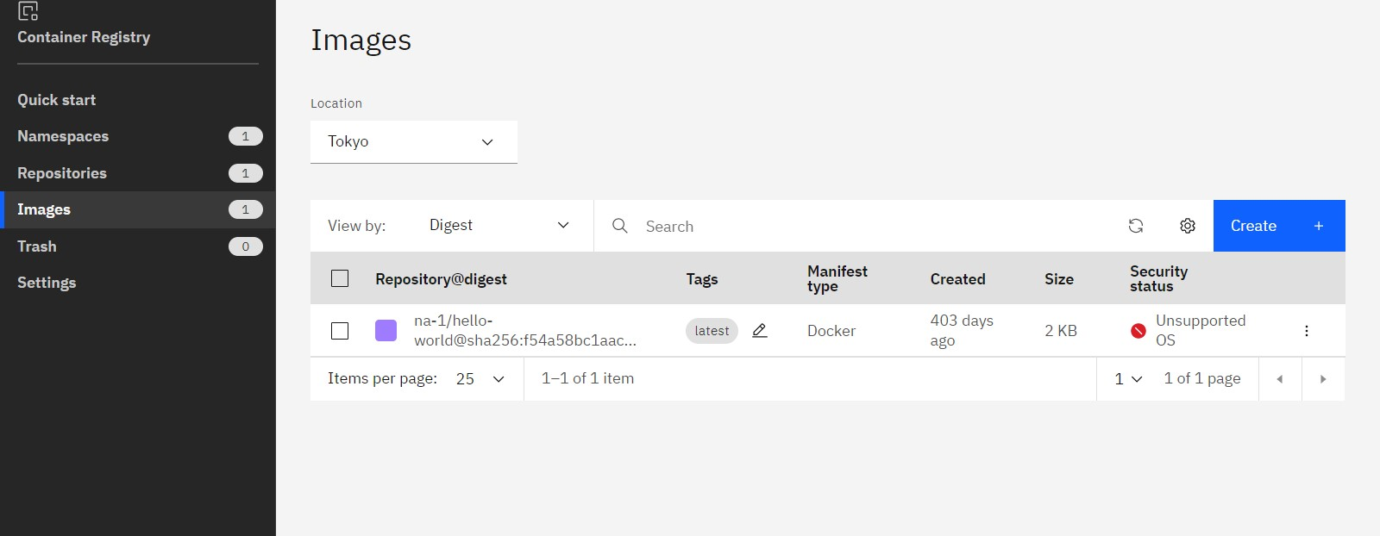

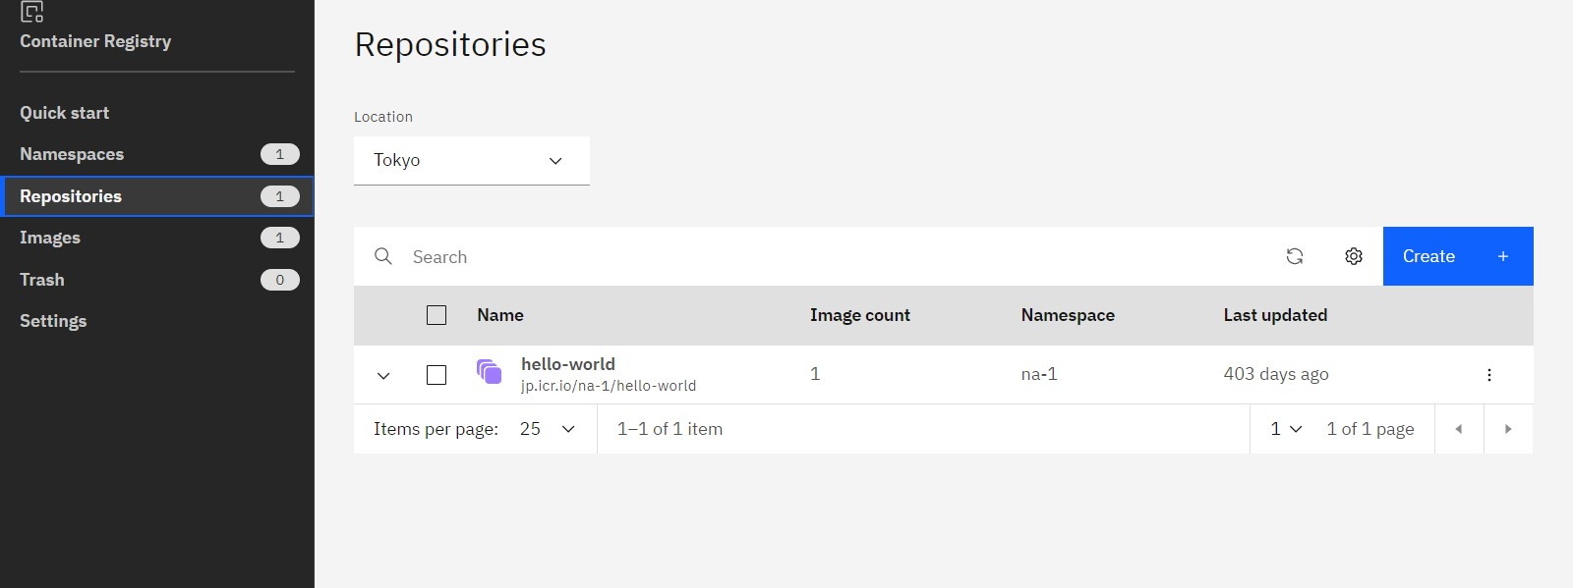

4.Create a Kubernetes cluster in IBM cloud and deploy flask application image or job portal image and also expose the same app to run in nodeport.

